Problem Statement

Python-based simulation of a GPS toll system.The biggest issue for travelers is unforeseen circumstances like as additional costs, primarily from toll gates.Traveling is uncomfortable due to the toll gate's precise location and expense.

Unique Idea Brief (Solution)

I have included extra library functions in this project that you did not mention earlier.   
Compared to other ones, this provides a simple to grasp and efficient one. There are no more complicated components in this project.

Features Offered

Travelers can use their mobile GPS devices to calculate the distance and amount needed for a comfortable trip.

Processflow

First, the map is integrated into our code. Next, we find the toll locations between the starting and destination. Finally, we use mathematical formulas to calculate the amount and distance.   
Finally, the location and amount of tolls are computed.  
Architecture Diagram  
 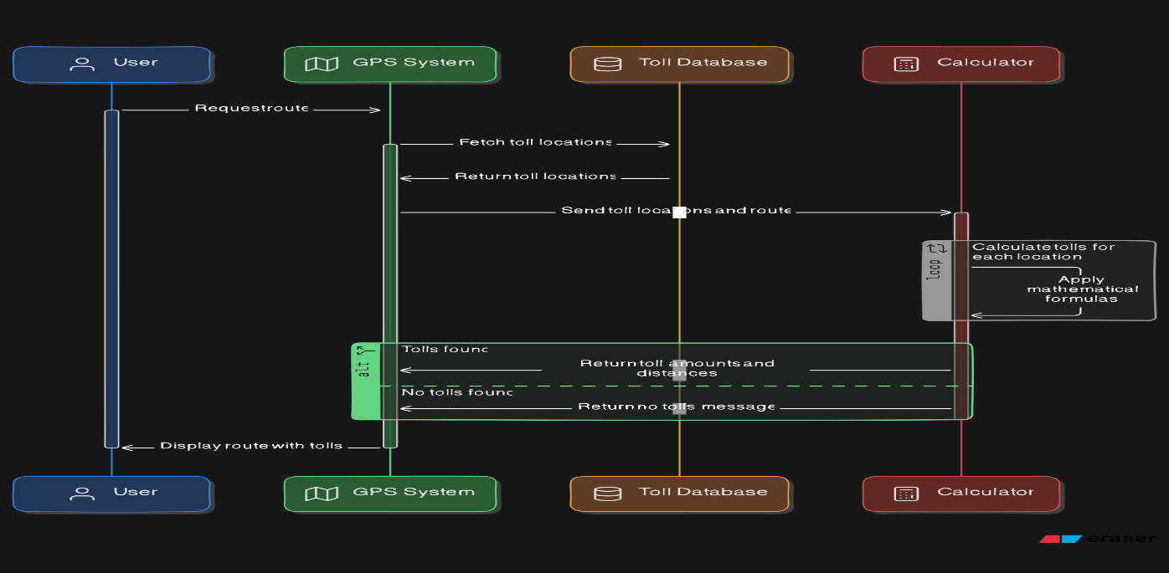

Technologies used

GPS data handling and analysis and then mapping and visualization

Team members and contribution:

Madhan S

I created the entire project myself.

Conclusion

I developed this project to make simplicity in trevelling